**E-MAIL VALIDATION BY USING FINITE AUTOMATA**

Dinesh

Bhanu Prakash

Krishna karthikeya

**Abstract:**

The Finite Automata-based Email Validation project proposes a systematic approach to automate the validation of email addresses using Finite Automata. The proliferation of digital communication underscores the importance of ensuring the accuracy and legitimacy of email addresses within databases and applications. Traditional manual validation processes are prone to errors and inefficiencies, necessitating the adoption of automated solutions for email validation.

In this project, we design and implement a Finite Automaton specifically tailored to validate email addresses against predefined patterns and rules. By encoding the structure and syntax of valid email addresses into the finite automaton, we create a deterministic process for efficiently validating email addresses entered into systems. The finite automaton traverses through the input email address, transitioning between states based on the characters encountered, and determines whether the email address adheres to the specified validation criteria.

**Introduction:**

Email validation is a crucial aspect of modern communication systems, ensuring that email addresses entered into applications or databases conform to the standard format and are reachable destinations. However, manual validation processes are cumbersome and error-prone, often leading to inefficiencies and inaccuracies in email databases. To address these challenges, automating email validation through Finite Automata (FA) presents an efficient and reliable solution.

Finite Automata, a mathematical model representing computational processes, offer a systematic approach to validate email addresses against predetermined patterns or rules. By constructing a finite automaton tailored to email address validation, organizations can streamline the validation process, improve data accuracy, and enhance overall system efficiency. This project aims to leverage Finite Automata to develop a robust email validation system capable of efficiently verifying the correctness and legitimacy of email addresses.

**PROPOSE SYSTEM:**

**1. System:**

The system will consist of a finite automaton designed specifically to recognize valid email addresses. Finite automata have a set of states, transitions between these states based on input symbols, and accepting states that define when the input string is accepted. In this case, the finite automaton will be designed to mimic the structure of a valid email address.

The finite automaton will transition through states as it reads each character of the input string. It will have states to represent different components of an email address, such as the local part, the "@" symbol, the domain name, and the top-level domain (TLD). Transitions between states will be determined based on the characters read from the input string.

**2. Test:**

The testing phase will involve creating a comprehensive set of test cases covering various scenarios:

- Valid email addresses with different combinations of characters.

- Invalid email addresses with incorrect formats or missing components.

- Edge cases such as email addresses with maximum lengths, minimum lengths, etc.

Each test case will be executed against the finite automaton, and the output will be compared against expected results. This comparison will verify whether the system correctly identifies valid and invalid email addresses.

**3. Input and Output:**

**- Input:** The input to the system will be a string representing an email address.

**- Output:** The output will indicate whether the input string represents a valid email address or not. If the input string is valid according to the defined rules, the output will indicate success. Otherwise, it will indicate failure.

**ARCHITECTURE:**

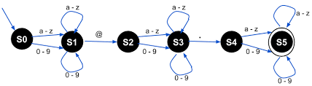

SOFTWARE DESIGN DOCUMENT [SDD]:

**USE CASE DIAGRAM**

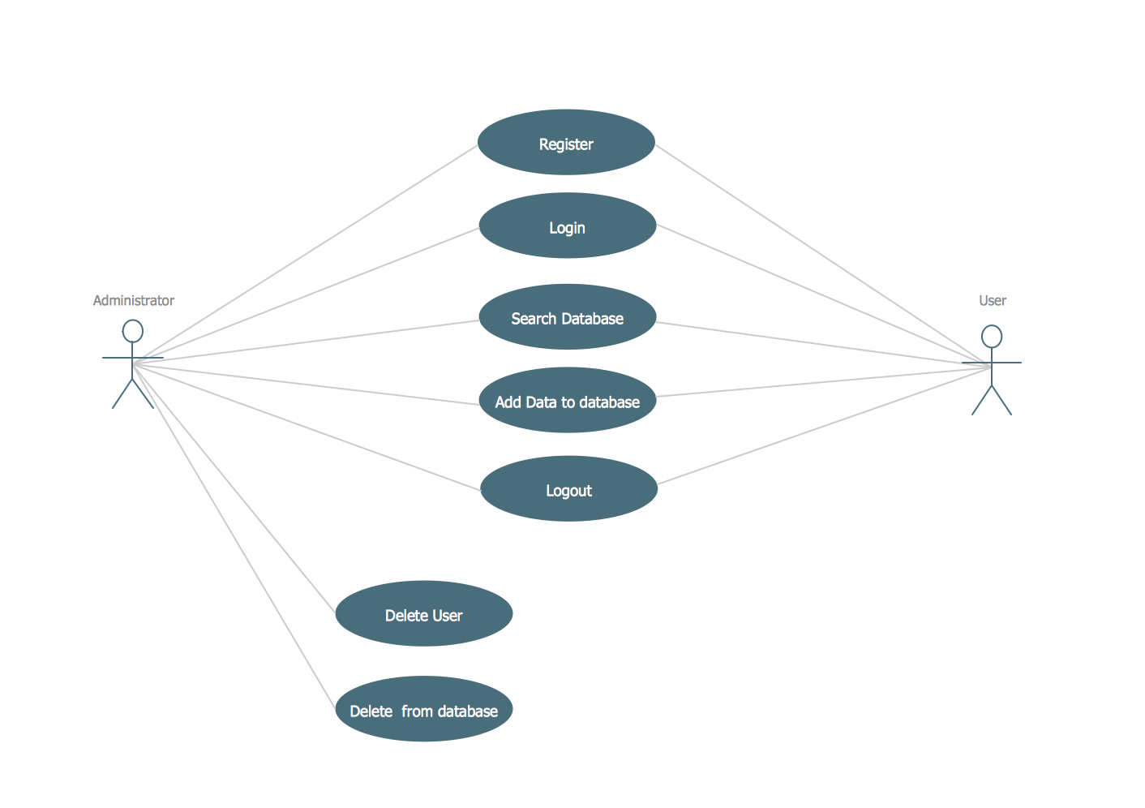

ACTIVITY DAIGRAM

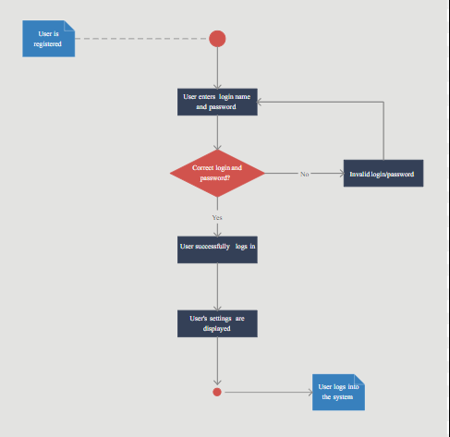

SOFTWARE REQUIREMENT SPECIFICATIONS [SRS]:

**Functional Requirements**:

1: Input Handling

- The system accepts input strings representing email addresses.

- Input strings may contain alphanumeric characters, special characters, and valid email address components (local part, "@", domain name, top-level domain).

2: Finite Automaton Implementation

- The system implements a finite automaton to validate email addresses.

- The finite automaton transition through states based on characters read from the input string.

- It shall have states representing different components of an email address (local part, "@", domain name, top-level domain).

- Transitions between states shall be determined by the characters read from the input string.

3: Validation Result Generation

- The system generates validation results indicating the success or failure of email address validation.

- If the input string represents a valid email address according to the defined rules, the system output a success indication.

- If the input string does not adhere to the standard email address format, the system output a failure indication.

**Non-functional Requirements**:

**1: Performance Requirements**

- The system provides email address validation with minimal latency.

- The response time for email address validation shall be less than 100 milliseconds.

- The system be capable of handling a large number of concurrent validation requests.

**2: Security Requirements**

- The system implements secure coding practices to prevent vulnerabilities such as injection attacks and buffer overflows.

- Input validation mechanisms be employed to sanitize input strings and prevent malicious inputs.

**3: Usability Requirements**

- The system provides a user-friendly interface for inputting email addresses and viewing validation results.

- Validation results be displayed in a clear and understandable format, indicating the validation status of email addresses.

This Software Requirements Specification outlines the functional and non-functional requirements for the development of an email validation system using finite automata. It serves as a guide for system design, development, and testing processes.

CONCLUSION:

The Email Validation System using finite automata outlined in this Software Requirements Specification (SRS) aims to provide a robust solution for verifying the adherence of input strings to standard email address formats. By leveraging finite automata, the system can efficiently recognize and validate email address patterns, ensuring accuracy and reliability in the validation process.